EXPERIMENT: 8
DATE:16.07.26
Depth-First Search (DFS)

Aim:

To write a Python program to implement the Depth-First Search (DFS) algorithm for graph traversal.

Algorithm:

- Read the number of vertices and edges.
- Create the graph using an adjacency list.
- Read the starting vertex.
- Mark the starting vertex as visited.
- Display the current vertex.
- Visit each unvisited adjacent vertex recursively.
- Repeat until all reachable vertices are visited.
- Display the DFS traversal.

Program:

graph = {}
n = int(input("Enter the number of vertices: "))
e = int(input("Enter the number of edges: "))
print("\nEnter the edges (source destination):")
for i in range(e):
u, v = input().split()
if u not in graph:
graph[u] = []
if v not in graph:
graph[v] = []
graph[u].append(v)
graph[v].append(u) # Remove this line for directed graph
start = input("\nEnter the starting vertex: ")
visited = set()
def dfs(vertex):
visited.add(vertex)
print(vertex, end=" ")
for neighbour in graph[vertex]:
if neighbour not in visited:
dfs(neighbour)
print("\nDFS Traversal:")
dfs(start)

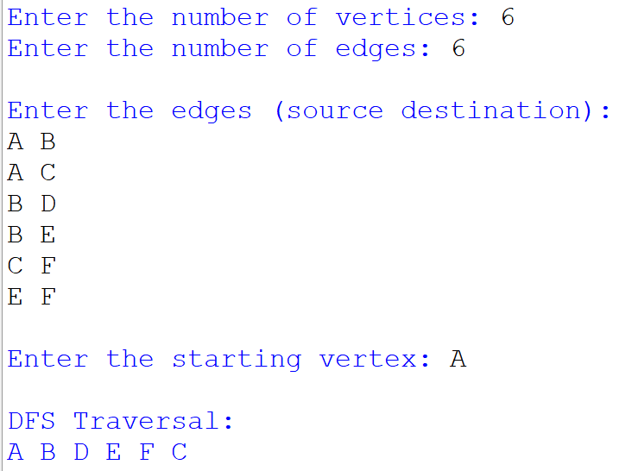
Output:

Result:

Thus, the Python program to implement the Depth-First Search (DFS) algorithm was successfully executed, and the graph was traversed in Depth-First Search order.

